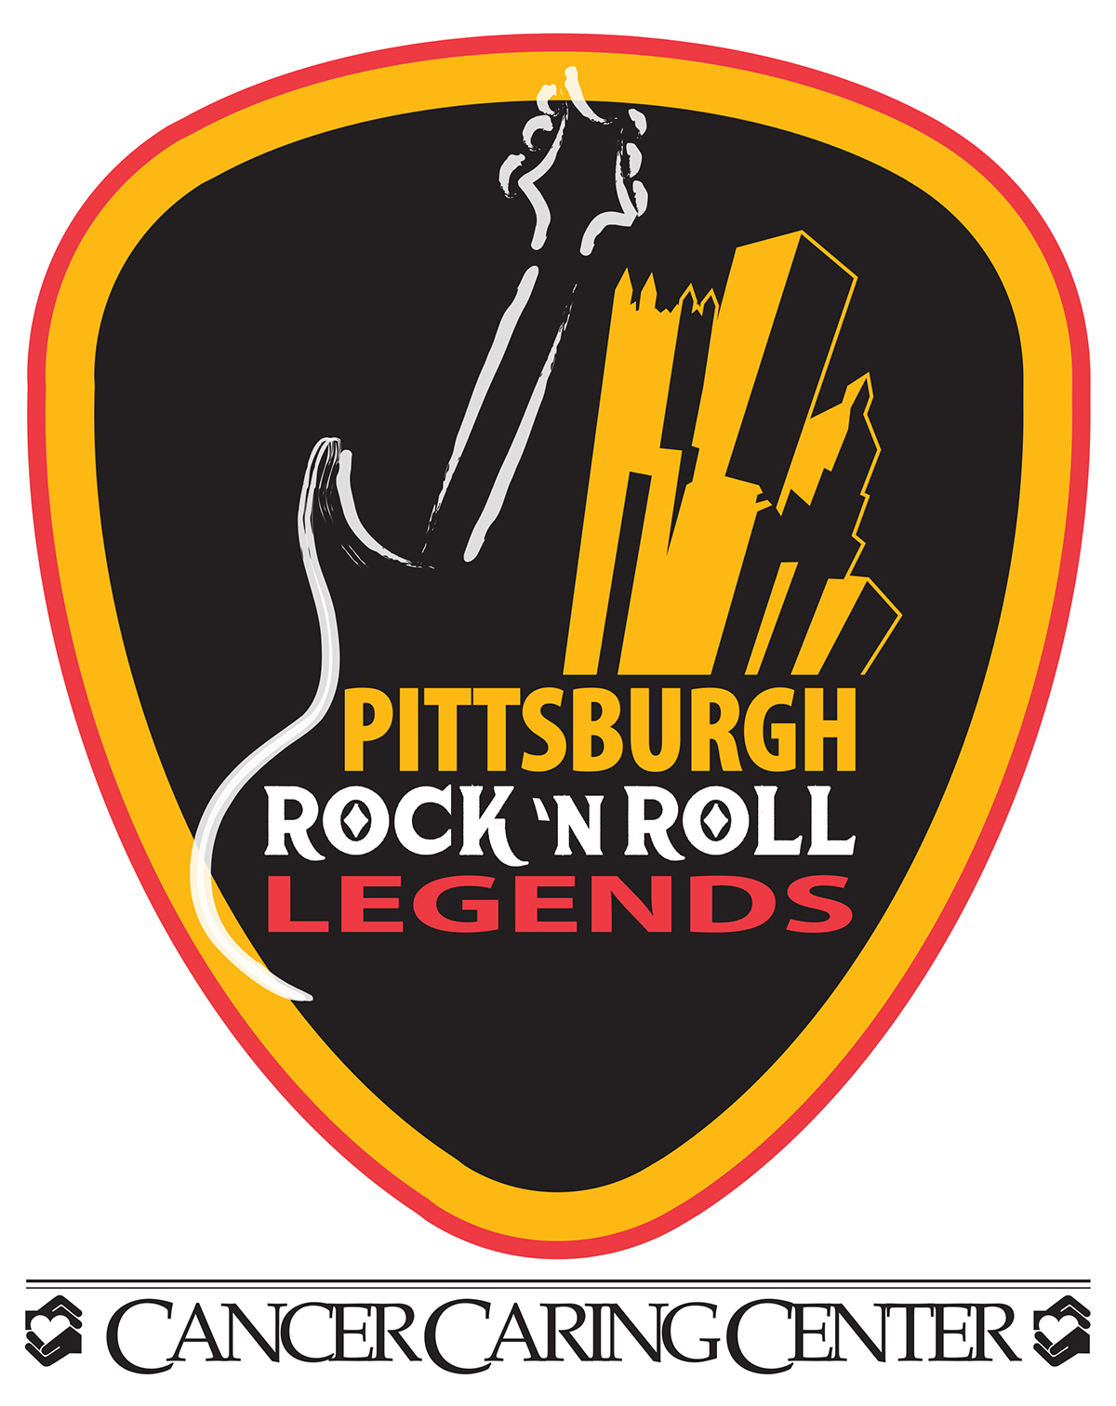

**CANCER CARING CENTER ANNOUNCES DATE,**

**VENUE AND NOMINEE SLATE**

**FOR FOURTH ANNUAL PITTSBURGH ROCK ‘N ROLL LEGENDS AWARDS™**

**PITTSBURGH - December 7, 2016** – The Pittsburgh-based Cancer Caring Center, which produces and hosts the *Pittsburgh Rock ‘N Roll Legends Awards* is moving its 2017 signature event to **Jergel’s Rhythm Grille in Warrendale**, where the rockin’ awards will be held on **Thursday, April 27, 2017**. This celebration will honor the tremendously talented individuals and organizations that have contributed to the rich history of rock and roll music in the Greater Pittsburgh region, while raising money for the Cancer Caring Center.

Legends nominees were selected by the highly knowledgeable **Legends Nominating Committee** in four categories, with input from the **Academy of Voters**. The 2017 nominees are:

* **Modern Era Legend (Solo performer or band with 20+ years in the business – 1 inductee)\***

⚫ The Clarks** ⚫ Rusted Root** ⚫ Tommy James & the Shondells**

* **Music Industry Professional Legend (Producer, promoter, manager, etc., with 20+ years in the business – 1 inductee)**

⚫ Charlie Brusco ⚫ Jerry Reed ⚫ Andy Warhol

* **Legacy Legend (Solo performer or band with 40+ years in the business – 1 inductee)**

⚫ The Jaggerz ⚫ The Vogues** ⚫ Del Vikings** ⚫ Bobby Vinton

* **Music Broadcaster Legend (DJ or VJ)** **with 20+ years in the business – 1 inductee)**

⚫ Chuck Brinkman ⚫ Clark Race ⚫ Jimmy Roach

**\*We have respectfully withdrawn the name of B. E. Taylor from nomination consideration at the request of his family. We will honor his important and lasting legacy at a future date.**

**\*\*Note: The most successful iteration of any band is the one nominated.**

Also, Alan Leeds, Eric Leeds and Matt Blistan will be recognized as the Pittsburgh Connection to the late musician Prince.

Winners of the 2017 awards will be selected through weighted votes cast by the general public and the Pittsburgh Rock ‘N Roll Legends Awards **Academy of Voters** – which is similar in make-up to the Nominating Committee - and comprised of nearly 200 local producers, promoters, music historians, musicians, media, educators and other industry professionals. Members of the public can register to receive a ballot by signing up now through February 5 at [www.PittsburghRockLegends.com.(Only](http://www.PittsburghRockLegends.com.(Only) one vote per email address will be allowed; no registrations accepted once voting begins.) Ballots will emailed February 8 to registered voters. Voting will be held from February 8-20. All votes will be reviewed and certified by an independent, volunteer third-party panel of judges comprised of a local CPA, a journalist and a federal court judge to assure that the voting process is fair and transparent. Winners will be announced in early March.

The 2016 honorees were Joe Grushecky and Billy Price (Modern Era), the Skyliners (Legacy), Pat DiCesare (Music Industry Professional) and Sean McDowell (Music Broadcaster Legend). The 2015 honorees were Donnie Iris (Modern Era), Porky Chedwick (Music Industry Professional) and Lou Christie (Legacy). Concert promoter Rich Engler, formerly of DiCesare Engler, was honored as the inaugural inductee in 2014.

For more about the **Pittsburgh Rock ‘N Roll Legends Awards**, or to learn more about sponsorship opportunities or auction prize donations, please contact Rebecca Whitlinger at 412-622-1212 or [rebecca@cancercaring.org](mailto:rebecca@cancercaring.org).

**About the Pittsburgh Rock ‘N Roll Legends Awards**

The Pittsburgh Rock ‘N Roll Legends Awards is a local registry that honors the tremendously talented individuals and organizations that have contributed to the rich history of rock and roll in the Pittsburgh region. Organizers of the Legends Awards and a team of leading local musicians and industry experts have created an entity that will, over time, recognize many individuals who have played an integral role in making rock and roll music part of the fabric of life in Western Pennsylvania. The permanent Legends display, created by Wendell August Forge**,** features a hand-crafted metal guitar and a vibrant and striking painting of the city skyline by highly regarded local artist Johno Prascak. It hangs prominently at the Hard Rock Cafe in Station Square and will be updated as new Legends members are inducted. Follow the Legends on Facebook and Twitter or visit the website at [www.PittsburghRockLegends.com](http://www.PittsburghRockLegends.com).

**About the Cancer Caring Center**

Since 1988, the Center has been a Pittsburgh-based charity, providing free emotional and social support services to patients and families. They help those affected by a cancer diagnosis move forward, by offering a wide variety of programming. Services include nearly 20 neighborhood support groups throughout the area, individual and couples counseling, a telephone helpline, a Food Pantry for qualifying patients, a Young Adults Cancer Support program (YACS), art therapy, reiki and much more. The Center also offers Pet Therapy for children in cooperation with Animal Friends and support groups for children who have a family member with cancer. For more information, visit [www.cancercaring.org](http://www.cancercaring.org). Follow on Facebook and Twitter.

Rebecca Whitlinger

Cancer Caring Center

(O) 412-622-1212

(C) 412-418-7486

[rebecca@cancercaring.org](mailto:rebecca@cancercaring.org)

**RELEASE: IMMEDIATE**

CONTACT: